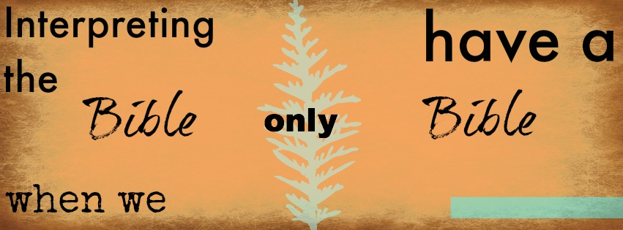
How do we interpret the Bible
. . . with only the Bible?

This means…no commentaries, theology books, footnotes, knowledge of original language, etc. In many (or most) missions contexts, resources are so limited. Most Christian communities will at least have the Bible.
This packet lays out a method of interpreting the Bible that anyone can use, even if he or she is a new Christian, is uneducated, or lacks resources.
This approach enables lay Christians both to test what they hear as well as contribute to discussions about the Bible. Accordingly, pastors and missionaries can establish sound DNA in churches, helping them not to be overly dependent on any single “expert.”

Who Needs
Interpretation When You
Have Theology?

Biblical interpretation is one of the most important and yet most neglected aspects of missions strategy. The problem is probably not restricted to missionaries. In my experience, very few churches train people in this particular skill.
Here are a few key ideas that highlight the importance of this subject.
People confuse theology and interpretation.
In other words, people confuse the process of interpretation itself with the conclusions that come out of that process. Doctrines are the result of interpretation. Understanding theological doctrines––no matter how complex and important they are––is not the same thing as knowing how to interpret the Bible.
The pastor or teacher becomes the functional authority of the church (not the Bible).

This happens whenever congregations or students do not know how to do interpretation. After all, the congregation does not know how to test the conclusions being taught. The average layperson often assumes that they simply don’t know enough or that the Bible is too hard to understand. So, they consent to taking the pastor (or the missionary) at his word. The pastor is the unchallenged “expert.” This is obviously not a healthy state.

I am constantly surprised and saddened at how intimidated people are about interpreting the Bible. People think that only “professional” Christians (i.e. pastors, scholars, missionaries) can interpret the Bible.
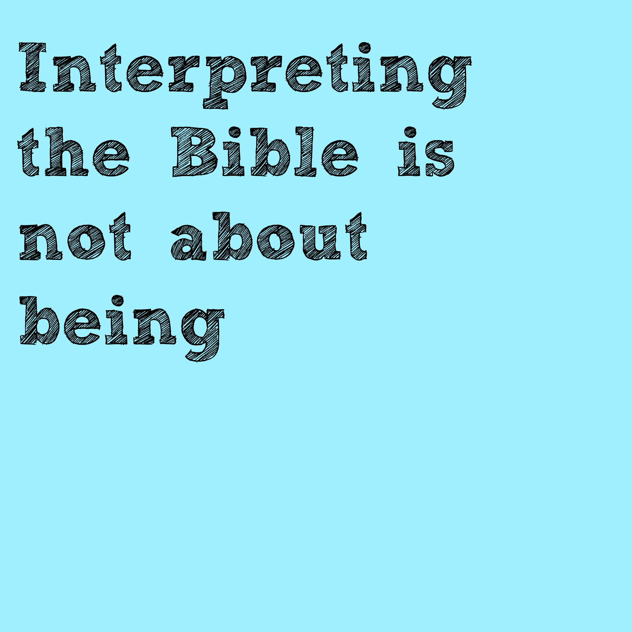

smart
Ironically, I know a number of missionaries who express their own anxiety about interpreting Scripture. Even they feel a daunting inadequacy.
Time and again, I have been in a study with very educated people who freeze, seemingly unable to tell me what the word “because” and “therefore” mean. In any other context, they would have no hesitation telling me what a certain sentence or paragraph means. When it comes to the Bible, however, they think they need a few commentaries, knowledge of Greek, and an upper-level seminary degree.
In the next section, I’ll point out a few very common but unhelpful things people do to interpret the Bible .

If we want to find the meaning of a biblical text, what things are not so helpful?

People often learn an inductive approach to interpretation, which consists of three steps:
What is not
very helpful?
1. Observation
2. Interpretation
3. Application

What’s the problem with this?
It never actually tells you how to interpret the Bible. There is an “interpretation” step within the methodology itself. People are still not told what to look for or what tangible steps should be taken and in what order.
Other tools that are not bad; yet, they are a bit arbitrary and might even emphasize application without fully handling the question of interpretation.
For example, some people teach the acronym SPECKA:
S = Sin (Is there a sin to confess?)
P = Promise (Is there a promise from God?)
E = Example (Is there an example to follow?)
C = Commands (Are there commands to obey?)
K = Knowledge (What does this passage teach us about God?
ourselves? others?)

A = Accountability (Where do we need accountability?)

Another common set of questions includes these four questions.
What does it say?
What does it mean?
What does it mean to me personally?
How can I specifically apply this to my life?

Notice that these Bible study methods do not actually tell you specifically how to discern the author’s original meaning. They seem to collapse interpretation into application.

What Does the Text Mean?
In Bible studies, the question is often asked,
“What does this text mean?”

I have often heard answers like this: “It means we should love others.” “We need to share the gospel more.” Or perhaps, “It means we should do a better job doing . . . .”

What’s the problem with this?
The problem is that neither John, Paul, Peter, Moses, nor any other biblical author had you or me specifically in mind when writing the letter or book.
People confuse the meaning of the text and its significance.
By “meaning,” I refer to what the author meant in his original setting. This is the primary goal of interpretation, yet I find few specifically prioritize this skill and so commit the errors mentioned above. Too often, people stress “significance,” i.e. application (“what the text means for me”).
This is dangerous tendency because we will inevitably force our own context into the Bible. Yet, our questions and assumptions are not necessarily those of the biblical writers. Whether we like it or not, even “conservatives” might wind up reading the Bible like “liberals,” who make the Bible to mean whatever they personally want it to mean.

We justify this tendency by saying we simply want to be practical. However, we must keep this idea in mind:
Right application should be rooted
in right interpretation.
What are we to do?
This will be the subject of the upcoming sections. They will offer a bookmark that believers can use whenever they read the Bible.
The following model was originally designed in Chinese. As a result, the verbiage was designed so that people could easily memorize the steps.
I have yet to figure out what memory devices could be used in English to teach the same content. Still working on it . . . .
The process is designed to makes us slow down!
It has five steps that could be summarized in this way:
述-印-境-提-释
Two Key
Principles
(shù – yìn – jìng – tí - shì)

Two of the most fundamental principles
of biblical interpretation include:

“Context is King”

Compared to other factors, “context” is most decisive for discerning the meaning of the text (not tradition, teachers, commentaries, etc.). “Context” includes the passages before and after the text we are presenting studying as well as any passages that are being cited from the Old Testament.

“Interpret Scripture with Scripture”

This second principle includes the first one above. Here we stress the fact that we should not interpret different passages in a contradictory way. Interpreters should use more clear Scripture passages in order to interpret less clear passages.
述-印-境-提-释

1. Restate the passage
In other words, use your own words to repeat and retell what the author says; however, do not interject your own interpretation.
As much as possible, don’t add your own understanding to the passage. If the meaning of a phrase or word is unclear, then simply restate the language it uses.
It’s not complicated.
It simply requires the humility to be patience and slow yourself down.
I find people initially really resist this step at first. Eventually, they come to appreciate it because the purpose is to slow us down so that we notice the subtle transitions, the author’s imagery and word choice, as well as any other details we missed in our initial casual read.
When you actually have to rephrase a text (being careful not to interpret it), you notice more things. Even small children can parrot what they don’t yet understand. In the same, way anyone can do this step.
2. What are your impressions?
We want to discover our own assumptions. What ideas do we bring to the text? Perhaps, we have read a book or heard a pastor teach on the subject. We’ve “heard” someone say something that seems like a reasonable interpretation. This type of question is ignored by typical interpretation methods.
Why is this question utterly critical?
Although the original meaning of the text doesn’t change, our interpretation of a passage certainly might shift depending on our assumption, background, and culture. We must be humble enough to distinguish what the Bible says and what we think it says (i.e. theology). Our knowledge is limited. Sin and misunderstanding can subtly distort our reading of the text.
The goal of this step is to state from the outset what the text appears to say in order to make explicit one's assumptions and default interpretation.
By stating our impressions, we can at least test those ideas. Too many people do not realize how their own backgrounds influence their reading of the text. At least this way, one takes intentional steps to assess the many ideas in their mind that usually go unnoticed.
This step is very helpful in an Asian context.
Why? Because there are no wrong answers!

Don’t forget: people only share their impressions and the things they have heard. We are asking: On the surface, what does it appear to say? The only possible “wrong” answer is if someone lies and says something that is not their impression.
We are not asking what the text means. The “meaning” of the text and our impressions about the texts are two different things. People’s impressions reflect their assumptions. Because assumptions subtly affect us in unseen ways, our assumptions are critically important. In the steps that follow, we will check whether these impressions are correct. After all, our assumptions may not fit reality.
Impressions
reflect
assumptions
I’ve heard people dismiss this concern because they say that Holy Spirit guides us so as to reveal truth. Frankly, this objection is naïve in this respect: we obviously know that Christians disagree, get things wrong, and misinterpret verses. Having the Spirit does not ensure omniscience. We need to be careful not to use the “Holy Spirit” card as a subtle way of validating our own interpretation against someone else’s.
If so, then we should take the problem seriously. We do so by adding a step at the front of our study in order to make our assumptions as clear as possible.
Our impressions may be correct,
but we still need to test them.

It may be the case that we have assumed something that is true but it may be the minor point of the passage and not the major idea. It is quite easy to confuse right/wrong and major/minor. We must guard against compromising the gospel by settling for truth.
Essentially, my book Saving God’s Face aims at dealing with this very question, i.e. the influence of the reader on his or her own theology.
3. What is the Context?

This step is so critical. We must ask the question, “What do I mean by “context?”

I include this information of the backside of the bookmark (at the end of this packet).
One of the most important rules of biblical interpretation is simply this: “Context is king.”
Context decides the meaning of a word, phrase, or idea. That means that neither our pastor, nor our footnotes at the bottom of our Bible, nor any famous teacher determines the meaning of the text.
This also means that not even tradition decides what the passage says. Regardless of how important evangelicals think a certain doctrine is, we have to look at the text afresh. After all, if a text “obviously” has the traditional meaning, then let the text speak for itself.
Chapter two of Saving God’s Face explains how evangelicals might commit a logical fallacy (“begging the question”) by “assuming” the gospel. This phrase obviously makes people a little concerned when they first read it. If you can’t assume the gospel, what can you assume?
The point however is rather straightforward. We tend to assume our personal articulation and our traditional emphasis is the essence of THE gospel. Yet, all we have to do is see the range of different gospel presentations in Scripture.
Briefly, I need to address my fellow Chinese speakers. I am well aware that 情境 is a bit vague and doesn’t convey “context” as well as we’d like.
Given the subject matter being discussed, a very general word is a bit more appropriate than a precise word that is too narrow.
4. Pose Questions
Notice I did not say answer questions.
The entire goal at this stage is to focus our attention on what we don’t know and what we think is most important to figure out. We simply want to brainstorm potentially relevant questions, whether seemingly basic or complex. By thinking of one simple question, we often discover other more substantial questions follow.
Why is this important? When we ask bad questions, we tend to get bad answers. The questions we ask focus our attention. Sometimes, we don’t realize what we don’t know until we actually try to think of such questions.
People truly need self-control not to answer the questions; otherwise they will very quickly go off on a tangent.
In addition, this stage can be very helpful for small groups. People will discover they share common questions. It will also spur others to consider issues and themes they had not previously thought about.
Finally, this step naturally allows people to admit what they don’t know! This is crucial in a face-saving culture. In this step, we are all “supposed” to say what it is that we don’t know. We have permission to admit ignorance.
What do we do after we’ve restated a text, given our impressions, examined the context, and clarified our question?
We explain it.
5. Explain the passage

At this point, people can get stuck and wonder, “What now?”
After making a so many observation, there is a temptation to randomly answer whatever question seems most pressing to you. We have to resist.
We need to interpret the passage in a way that suits the context (step #3). In any given text, there is a sequence of thought or a plot that should direct our flow of conversation.
For example, we typically should not try to interpret v. 10 of a chapter before reflecting on verse 3–6. There will be any number of logical transitions and intertwined details. These are crucial if we are going to catch the writer’s intended meaning. Order matters.
There is a serious danger that lurks at this stage. People are tempted to forget all they have studied for the previous 4 steps and jump directly to some other book that they think is a great cross-reference.
Most people are taught systematic theology more than biblical theology (including exegesis skills).

Therefore, instead of putting all their observations together, they default to the old habit of proof-texting. Perhaps, the other passage is relevant and makes a great point. However, settling for that other book’s message may mean overlooking what this text is saying and how it says it.
Therefore, the main way they know to “interpret” Scripture is simply to piece together verses from all over the place and put them together in some system. This is a bad habit.
People may well affirm an important truth; however, that particular truth has nothing to do with the particular text they are studying. So often, someone starts majoring on the minor point.
This habit is worst among two types of people.

(1) People with hold to a very traditional theology. They are eager to make sure they never veer from the most common interpretation.
(2) People who are attracted to controversial topics and places with unclear wording.

If the first four steps are done well, the last step is as exciting as it is easy. I’ve seen groups that are typically shy and unsure of themselves really start to open up because they have patiently and methodically reflected on the entire passage. If you only had an hour to do interpretation, I suspect this last step would only use about 10–15, minutes. The first 45–50 minutes are spent on the first 4 parts.

If we want to read the Bible wisely, we will slow ourselves down, ask questions, and listen
In my experience, this is not the normal routine. I find that people try to explain a passage right from the beginning. Consequently, the rest of the time is largely spent arguing about competing opinions based merely on someone’s impressions or on their Bible commentary notes.
This is certainly not the most fruitful way to interpret and discuss a text.
What does the Bible say?
Studying context is the single most important step in the interpretation process.
What is the “context” of Scripture?

If so, we have to ask, “What is context?”
Most of the methods I’ve seen do not give adequate and balanced attention to “context.” As a result, preconceived theological ideas can subtle take over our reading of the text. This a major gap in the process.
上文
下文
脉落
主题
隐喻
比较
主脉 比喻 (shàngxià zhǔmài bǐyù)
上文– Prior Context
What comes before the passage we’re studying? How does what came before lead to our present passage? The immediate prior paragraph(s) are most important.

Mind the
gap

This prior context also includes quotes and allusions to events in the Old Testament. We need to first understand what a line meant in its original OT context. Only then can we grasp its full significance in the passage that we are studying.
下文– Post Context
How does our passage lead to and support what follows? As best as possible, we need to be familiar with the key ideas and message of the paragraphs (and chapters) that follow. Various writers repeat certain ideas, words, and themes throughout their book(s). Additionally, the theology in the first part of an epistle informs the applications in the letters’ second half.
主题– Themes
What are the big themes that the passage references? Interpreters often struggle to distinguish primary and secondary ideas. If we want to have any hope of doing so, we need to slow ourselves down and identify the range of concepts and ideas presented in the text.
脉落– Sequence of Thought
This step makes a big difference in finding exceptional insights that go beyond whatever seems to be the plain meaning of the text.
As much as it possible, our goal must constantly be to think the Bible’s thoughts after it. This means that we insist on grasping the flow of the author’s argument or story. Where are the logical transitions? How does one thought stem from and lead to other ideas?
In every class I teach, I ask my students the same question: “What are the most important words in the Bible?” It’s not “love”, “cross,” “salvation,” etc. I tell them . . . .

The most important words in the Bible are conjunctions!

(By way of reminder, conjunction is “a word that connects (conjoins) parts of a sentence.” These are words like “therefore”, “because”, “since”, “in order to”, “but”, “so that”, “if”, etc.)
Additionally, we want to identify the “units of thought” within the passage. A story or argument is usually put together in chunks. Typically, 4-8 sentences will assert or defend a thought before giving way to another set of sentences designed to make a particular point.
No one can retain all the individual words, phrase and sentences of a book. Therefore (← this is a conjunction), it is critical that we group ideas in units of thought that help us grab hold of the big picture, the author’s broad flow of thought. That is something we can remember and apply much easier.

比较– Comparison
On nearly every page of the Bible, one will find a flurry of comparisons or contrasts aimed to drive home a point or provoke a response. Sometimes they are subtle––using word images. Perhaps, they are separated by a few sentences. Very often, when identifying themes in a passage, you will notice that a comparison/contrast is being made.
This is an easy step that easily gets overlooked.

Why We Need Metaphors, Character, and Common Sense

隐喻– Metaphors
Sadly, I’m rather confident that this step will be ignored by most of my readers. However, metaphors are like a treasure map for biblical interpretation. A wealth of insights lies buried beneath their verbal imagery. (←This is a metaphor.)
Consider Romans 5–8. We orient ourselves by first identifying its key metaphors. “Sin” for example is depicted as a slave master that reigns over us and pays us a “wage” of death. If we miss this pervasive imagery, we will quickly go adrift and sink in murky waters of Romans 7 before anchoring at the shores of chapter 8.

We unconsciously use metaphors everyday.
Unlike my last paragraph, most metaphors are subtle. Humans throughout history and across cultures––like those in the Bible––have employed various images as a way of saying more than the “plain meaning” of the words themselves. Abstract ideas are expressed in concrete language.

God reveals himself in metaphors. So why do we tend to read past them?
The word “salvation” itself is a metaphor (“being saved”). It is explained using countless other terms, like redemption, atonement, justification, glorification, adoption, election, union, forgiveness, washing, resurrection, rebirth, etc . . .
We take metaphors for granted. Though having eyes, we do not see them. Regaining the ability to see these word pictures and symbolic analogies takes practice. It’s a skill that is lost when we are casual about words. This is most tragic when we’re talking about the words of God.

Two books that examine how metaphors
are used either in Scripture
or in modern cultures.
Adopted into God’s Family: Exploring a Pauline Metaphor
Metaphors, Culture, and Worldview: The Case of American English and the Chinese Language

Bad memory? Forget about it.
Some people think they have to be super smart, analytical, or have a great memory to understand the Bible. Such ideas are mistaken. There are a few reasons for this.
1. Simplicity is memorable.
These six steps are also easy to remember because they can naturally be lumped into three commonly used word groups: 上下 (shàngxià, “before and after”), 主脉 (zhǔmài, “main thread”), 比喻 (bǐyù, “analogies/metaphors”). Therefore, even if one were to forget these six Chinese characters, their meaning is built into three simple words.
上下––主脉––比喻 (shàngxià––zhǔmài––bǐyù)
2. What we really needed is a little more imagination.
When we understand that the Bible is one big narrative, not merely a patched together collection of little stories, then we can more easily enter into that grand narrative. The biblical story becomes our story. No one has to “memorize” his or her life story.
At that point, interpretation can become more and more instinctive rather than mechanical. That is, the biblical story increasing acts as a lens for seeing the world. It becomes the context in which we live rather than a theological argument we look at.

If you want to read more on this, here are two great books.
The Drama of Scripture
(by Craig Bartholomew and Michael Goheen)

The Drama of Doctrine: A Canonical Linguistic Approach to Christian Doctrine
(by Kevin Vanhoozer)

We simply need character and common sense
If you review the process laid out above, you will notice that there is nothing at all that requires “brilliance” or a PhD in theology. More than anything, it simply requires us to slow down.
Step one is essentially paraphrasing. Step two asks us to give our impressions. They don’t even have to be right! Step three doesn’t ask us to do anything beyond what we do everyday that we read email, a web page, or any other book. Step four is simply asking questions about what we don’t know. In fact, we need only admit we don’t know everything. The final and fifth step tells us to go back slowly over the text again, explaining each sentence and paragraph, one by one, using what you’ve observed.
More than anything, we need character.
We need the character to slow down and admit we don’t know something. We need the character to admit that we often assume too much and think answering these simple questions is too elementary for us.
If “common sense” is defined as the most basic knowledge we use everyday, then reading the Bible requires nothing more than some common sense. Why? At one level, we are using the same words that you’ll find on a blog or in a magazine.

- No one thinks the words “therefore,” “because,” and “so that” are hard to understand, except when they are in the Bible.

- No one reads the 7th sentence of an email as if it had little to do with the 3rd sentence (i.e. its context).

- No one gets tired faster than the average person who reads the Bible. For hours, he or she can read blogs and books like the Hunger Games and Harry Potter.

Why?
In part, it’s because we think basic biblical interpretation is harder than it really is. In so doing, we open ourselves to so many other deceptions.

One Last but Key Point

Theologian John Walton summarizes things well when he says,
“The Bible was written for us, not to us.”
What does this mean? The biblical authors wrote their books and letters with a particular context and set of readers in mind. The biblical authors asked the same questions and stress the same ideas that we would want to know about.
Therefore, we cannot assume the Bible answers the questions we might have. Perhaps, the author and his readers face different issues. The questions we ask will greatly influence the answers we arrive at. Interpreters should be careful to pay attention to the difference in the original and contemporary contexts.
Application
(What’s the significance of the passage?)

How do we apply this passage? We ask these four questions in order.

Honor
1. How does the passage honor God?

How does it highlight God’s worth, actions, character, and nature?

2. How should the passage influence our thinking?
Head
Positively, what should we think?
Negatively, what should we not think?

3. How does the passage influence our heart?

Positively, what should we feel and desire?
Heart
Negatively, what should we not feel and desire?

4. How does the passage influence our actions?

Positively, what should we think?
Hands
Negatively, what should we not do?

Mark 12:29–31

Jesus answered, “The most important is, ‘Hear, O Israel: The Lord our God, the Lord is one. And you shall love the Lord your God with all your heart and with all your soul and with all your mind and with all your strength.’ The second is this: ‘You shall love your neighbor as yourself.’ There is no other commandment greater than these.”

In Mandarin “meaning” is 意思 whereas significance is 意义.
重述, chóngshù.
印象, yìnxiàng.
情境, qíngjìng.
提问, tíwèn.
解释, jiěshì.
Or, one could speak about “contrast” (对比, duìbǐ).

