The Creator King uses the grand story of the Bible to help people understand the gospel of Jesus Christ.

It is not a typical “gospel tract.” This booklet is specially designed. Rather than highlight a few doctrines and principles, The Creator King helps people understand how the entire Bible fits together to reveal God’s character and works in history. After all, the truth of the gospel is “according to the Scriptures” (Rom 1:1–2; 1 Cor 15:3–4).

The gospel changes the way people see the world. It tells a story, not a philosophy. As a result, we have to rethink the way we present the gospel.
How to use The Creator King

.

Who is this guide for?

This guide was designed with two people in mind. On the one hand, The Creator King is an introduction to the gospel for non-Christians. For many non-believers, the gospel seems otherworldly or too philosophical. They do not see how God is relevant to their lives.

On the other hand, this gospel guide can be used as a tool to train Christians to communicate the gospel more clearly and confidently. Many believers don’t share the gospel because they don’t sufficiently understand the Bible. Although they can answer basic questions about Christ’s identity and his ministry, their knowledge is narrow and shallow.

What’s different?

Think about how people use traditional gospel tracts. Frequently, people will distribute gospel tracts to strangers but without any added explanation. As a result, unbelievers have difficulty understanding the meaning of the tract, either feeling its too abstract or that it’s not relevant to their lives. The problem is compounded by common feature in many gospel tracts. In order to simplify the message, tracts often focus on a few key doctrines. They rarely stress the Old Testament.

Non-Christians don’t have enough background knowledge to make sense of the presentation. As a result, the gospel can sound too abstract.

The Creator King takes a different approach. It focuses on the big picture so that people can better see that gospel proclaims a big God! In Christ, God entered our world and revealed himself in history. Our God is not distant or abstract.

When people understand the gospel as a story (and not merely a series of propositions), they better grasp the fact that the gospel presents an entirely different view of the world. They see that this gospel is relevant to their lives.

Don’t memorize. Do internalize.

The Creator King is a gospel guide.

People don’t need to memorize it. If someone were to ask us about our family or to share our family background, we would not need to memorize a set presentation. The gospel retells a story. Naturally, some aspects of the gospel never change; however, we have flexibility in the way we tell the story. As a “gospel guide”, The Creator King helps people to internalize the Story.

We are primarily supposed to share the gospel, not distribute it.

One small booklet by itself is insufficient. People need a personal explanation. We need to answer people’s questions. This means that those who share the gospel also need to know the story well.

Remember the gospel

How does this guide help people remember the Story? The Creator King has a few features that make it easier for people to share the gospel story.

SIMPLE PICTURES

For example, each section has a corresponding picture to help people remember key aspects of the story. Ultimately, the various smaller pictures come together to form a single picture that depicts the main points in the gospel story.

Accordingly, people could choose simply to remember a single image in their mind. That picture contains everything they need to remind them of the Bible’s grand story. These simple pictures can be drawn in the sand or sketched on a piece of paper. The pictures consist of simple shapes, like circles and triangles. You don’t even have to be an artist.

(Below, you will find a simple explanation about the symbolism and significance of the shapes.)

BASIC OUTLINE

The Creator King uses a basic outline to retell the gospel story. The plot is streamlined. The number of characters is minimized. Each section naturally flows into the section that follows. The presentation tries to limit the number of turning points in order to minimize complexity yet without compromising the Bible’s fundamental storyline.

REPEATING THEMES

A few key themes are interwoven through the various sections. They form a common thread that conveys the meaning and unity of the Bible’s grand story.

Accordingly, those who use The Creator King have a great deal of flexibility in how the share the gospel. One part of the story naturally reminds people of other parts. In addition, people have the freedom to emphasize one another theme as needed. With one person, they may highlight the fact that God is a Father and we are his children. With other people, we might choose to stress other metaphors, like honor or purity.

When sharing the gospel, people often are afraid that they must communicate the message in a very precise manner. If they forget one small detail or logical sequence, they will mess up the entire presentation.

The Creator King allows people to tell one story in a way that is suitable for all people.

PICTORAL BOOKMARK

You can use the The Creator King bookmark to guide other people through the story. By carrying the bookmark wherever you go, you will be reminded to share the gospel. Not only does it equip the Christian, it can spur conversation with non-believers.

Three ways to use The Creator King

1
- Train Christians

First of all, The Creator King can be used to train Christians to share the gospel effectively. As people understand the message, they will more naturally and boldly tell others

2
- Gospel Introduction

The Creator King introduces the broad storyline and raises curiosity. If people want to hear more about this message, we can use it as a guide for a further study.

- Evangelistic Study

The Creator King contains a number of questions to facilitate deeper discussion. Believers can use The Creator King to lead an evangelistic study. Perhaps, you could meet with unbelievers 4–6 times. Each time, your study time could focus on one major aspect of the story. Scripture passages have been added to assist further reflection.

3

Key Symbols

The pictures give a basic outline of the gospel story. They are merely symbols and reminders. People should not feel restricted by them. Rather, they provide people with a lot of flexibility. Your presentations may be as complex or as simple as needed.

The first set of pictures summarizes the Old Testament.

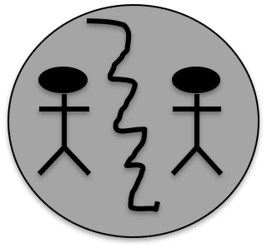
The triangle represents the history and calling of Israel, beginning from God’s covenant with Abraham through the exile. The triangle is a basic symbol for a Temple, which signifies God’s presence with His people. Note the coloring. Israel suffers from the same problem as the nations.

The large circle represents the fact that God created the world. Within the world, He made humans in his image. As Creator, God is both Father and King. The human family is called to honor Him. (Eventually, the relational triangle will have significance.)
God
The world is stained with dishonor (note the shading). The human family is divided against one another. Notice that the human figures have been enlarged and “God” is not represented in the picture. This signifies the worldview of fallen sinners.

The second set of picture express how God keeps his promises in the New Testament.

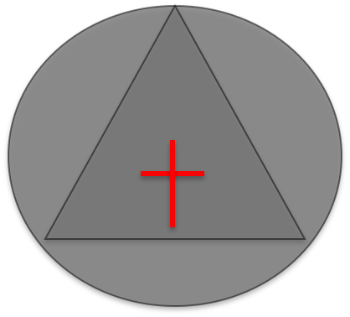
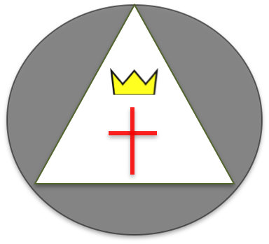

The cross represents the life and death of Jesus Christ, whose ministry only makes sense in the context of Israel’s history and calling. By his death, Jesus became a curse in order to bless the nations.

Jesus’ death not only purifies the Temple (i.e. God’s people), his resurrection declares that he the King of glory. Note the contrasting colors. The world is fundamentally divided into two groups––those who follow Jesus and those who rebel.

The triangle is enlarged and the darker circle has been removed. God purges the world of sin and death.

Review the first pictures above. Since the beginning, God has foreshadowed God’s ultimate plan to rescue the world. He finally makes the world to serve as a Temple, the place where God dwells with his people. They are his royal priesthood in the world.

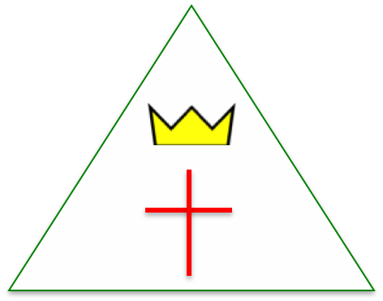
Important Suggestions

Overall Goals (central themes and emphases)

This gospel guide has an intentional design. It uses six major movements that shape the Bible’s main story line. God reveals himself in history. He enters into the lives of people. It is through God’s relationship with Israel that we see God’s plan, character, and nature. If gospel presentations do not include God’s Old Testament revelation, we have no way of understanding Jesus’ identity and works. Conversely, Jesus Christ becomes the key to understanding the Old Testament story and its promises.

A major value of The Creator King is balance. Our gospel presentations should reflect those things that the Bible itself emphasizes, otherwise, we may little by little begin to veer from the gospel’s focus.

The purpose of this gospel presentation is to magnify the character and plan of God. It centers on God rather than people. The gospel inherently is God-centered.

Instead of being limited to legal metaphors, this presentation intertwines a number of themes together. God as Creator is King. His plan is to use covenants to set his kingdom right, to establish a holy people. Although the human family in the beginning dishonored God, He vindicated His honor in Christ and restores us to a position of glory.

These metaphors give us a great deal of flexibility to preach the gospel. Depending on the specific circumstances, we can emphasize different themes or aspects of the gospel story.

Specific Tips For Each Section

- Start with the circle, making the point that God is the Creator. Afterwards, draw the two lines from “God” to the two people-figures. This indicates that we come from God, who is our Father.
- Draw the connecting line between the two people. We can point out that the relationship between people depends on our being related to God our Father.
- Take the opportunity to highlight the fact that we originally had harmony within the human family.
- At this point, I don’t suggest mentioning the symbolic meaning of the triangle. Simply make sure that people grasp God’s plan for the world, to be the place where God dwells with humanity.
- This comment is for Christians. Some people do not prefer to say that humans are God’s family / children. They are afraid that non-believers that only Christians in some sense can be considered God’s sons and daughters. We should keep in mind two points. First, Paul in Acts 17 is willing to say that all humans are God’s offspring. Second, conversion to Christ essentially entails the restoring of a person to his or her true family.

God

- This stage begins with human relationships in order to point towards humanity root problem. These human people might include family, siblings, friends, clan, society, and nation. Social divisions may be according to culture, education, social class, economics, gender, bloodline, ethnicity, etc.
- The break in relationship between humanity and God leads to the division in human relationships.
- Because humanity loses “face” (i.e. honor before God) in this way, people begin to struggle to achieve “face” (i.e. social recognition). This competition with one another makes people magnify themselves and people like them. We also settle for the unity of our social groups, but this cannot compensate for the lose harmony within the human family.
- Here, we want people to consider their loyalty, sense of identity and sense of belonging in order that they would reflect upon their relationship with God.

- The third stage is very important. It introduces God’s plan for setting the world right (e.g. the Abrahamic covenant; Gen 12). This stage prepares people to understand how God will use Israel to save the world. Apart from this stage, the fourth stage would be hard to understand.
- The one giving an explanation should notice the triangle connects the prior context and context to follow. Israel built a Temple. Because it is the place where God dwells with his people, it points ahead to God’s fulfilling his original design for the world. (Compare stage one and stage six).
- People have freedom to narrate various aspect of Israel’s history，such as Abraham, the Exodus, David, and the exile.
- People also need to observe that although Israel is God’s plan for world，nevertheless they too meet the same problem as the nations.

- Notice that the cross is places within the triangle. This is because Jesus comes from Israel. He is Israel’s hope.
- This picture also lets people present Jesus as a sin offering, represented as being within the Temple.
- Note that the picture increasingly centers on Jesus (the cross being placed in the center).
- As the center of history, Jesus’ life story and death will accomplish God’s plan.
- Although this part highlights the fact that Jesus defeats his enemies, we do not yet discuss the resurrection.

- The triangle not only replaces the circle; it also becomes larger. The triangle represents God’s original plan for the world (making to be a temple).
- In the end, the disappearance of the circles signifies God’s judgment against the impurity, shame, sin and evil that plague the world.
- Since the world has become a temple, this implies that people from all nations now belong to God’s holy and honorable people. The human family has been restored in keeping with the promise to Abraham.

- Clearly, the biggest changes include (1) the difference in colors, and (2) the added crown.
- The white area represents Jesus cleansing the temple (i.e. his people, the church).
- The crown represents Jesus’ resurrection and kingship. He reigns over his people.
- The contrast in colors points to the world’s two kinds of people (followers of Jesus and those who are unbelievers). We should explain that conversion involves making a decision about one’s belonging and loyalty. People change membership from one group to a new group (e.g. family, kingdom).

An Explanation of the Response Section

1. How does this presentation lead people to respond?

This presentation draws people by focusing on God’s historical revelation of His own character and works. Perhaps unwittingly, some presentations primarily highlight personal benefits in order to attract people. These benefits include eternal life, peace, and happiness. Consequently, listeners are attracted to blessings rather than to God.

The presentation leads to a clear invitation. Because it primarily emphasizes God’s kingship, people know the appropriate response is give allegiance (not merely intellectual assent). God wants our exclusive loyalty and uttermost trust.

“The Creator King” shows the group identity and our response to God are inter-related. How we respond to God will change the source of our identity, sense of belong, and sense of identification with others. Believers most certainly should place great value on the church; that is, our new family. For this reason, we cannot seek our “face”, identity, and value from the world.

Because we present a historical account, listeners more grasp the nature of required response. One’s response should be specific or concrete, changing the head, heart and hands. Because we share a coherent story (not merely a few propositions), it affects a person’s worldview.

Finally, this presentation prepares people for living the life of a disciple. How people come to faith in Christ will influence how they thereafter follow him. This process of evangelization will shape the development of their theology.

2. Why does it not have a “sinner’s prayer?”

We must keep in mind that any sort of “sinner’s prayer” inherently cannot make someone become a Christian. Ideally, this kind of prayer can do nothing more provide an external indication that someone has faith. Only faith saves a person. If people hear and believe this gospel story, then at that very moment, they have already become Christians.

However, if faith and a “sinner’s prayer” are too closely linked together, listeners can easily confuse faith and the prayer. People need changed hearts. Those who preach the gospel cannot see a person’s heart. Therefore, have a responsibility to make clear what is the gospel and its requirement (i.e. faith or allegiance).

If we are not careful, we will unwittingly make the “sinner’s prayer” become a requirement of the gospel. In fact, in the Bible, it is baptism that acts as the public confession of a person’s faith.

If you still want to use some sort of prayer, I urge people to first acknowledge the person’s faith (i.e. which, if genuine, means that he or she has become a Christ-follower), then after a few minutes, you could use a prayer to express thanksgiving to God for what he has already accomplished. Make sure this prayer of thanksgiving to God has not connection to how a person gains salvation.

